# GUIDELINES FOR PREPARING ARTICLES FOR Telematica magazine

**First Author (full name)1, Second Author (full name)2**

1Institution, address, 2Institution, address

1e-mail:

2e-mail:

ABSTRACT

The current document provides guidelines for preparing your article and to be considered by the Scientific Committee of the Telematics Journal. Please, use this document as a template, note the following concerns in particular: your article should be written on a single column within the margins established in this format (size A4 paper, top and bottom margins of 2.5 cm and left and right margins 3 cm), the abstract should be written with no less than 150 words and not exceed 250 words, use the font Times New Roman 10 pt and single-spaced lines, references should be ordered numerically according to their references on text, figures must exhibit high-quality graphics and together to tables should be properly included with the text, the nomenclature of used symbols should be completely declared as well as the proper units, the use of SI international system of units is also required. The paper can be written in Spanish or English but the use of English and Spanish (please use the Spanish template) languages to write the title, abstract and keywords is mandatory, the article should have a recommended length between 6 and 15 pages.

KEYWORDS: About five keywords or phrases, separated by commas (,).

# **INSTRUCCIONES PARA LA PRESENTACIÓN DE ARTÍCULOS EN LA REVISTA TELEMATICA**

RESUMEN

A continuación se describen las instrucciones para preparar su artículo y enviarlo a consideración del Comité Científico de la revista Telemática. Por favor tome en cuenta los siguientes puntos en particular: escriba el texto de su artículo a una sola columna dentro de los márgenes ya establecidos en este formato (tamaño de papel A4, márgenes superior e inferior de 2,5cm y márgenes derecho e izquierdo de 3 cm); no imprima ningún marco alrededor del texto; el resumen debe ser escrito con un máximo de 250 palabras; use el tipo de letra 10 pt Times New Roman y renglones con interlineado sencillo; las referencias deben tener un orden numérico de acuerdo a como van apareciendo en el texto; las figuras deben ser de buena calidad y junto con las tablas deben estar intercaladas en el texto; deben ser declaradas convenientemente toda la nomenclatura de los símbolos empleados y las unidades correspondientes; el uso del sistema internacional SI de unidades es obligatorio; el artículo debe ser escrito en español con escritura en inglés y español del título, resumen y palabras claves; el artículo debe tener una extensión recomendada entre 6 y 15 páginas.

PALABRAS CLAVES: Anote hasta un máximo de cinco palabras o frases, separadas por comas (,).

1. INTRODUCTION

Text formatting of the article

You may write directly your paper by using this template document. The text should be written to a single column with simple and justified spacing. Use the Times New Roman typeface or its equivalent. The font size to use is 10 points. Each time it starts a new paragraph leave an extra blank line (space). The wording will be impersonal. Abbreviations will be omitted and the acronyms must appear with their meaning duly clarified. Writing should be avoided through the use of bullets or numbered lists.

The summary must be located on the first page of the article. The first Section of the article should be "Introduction" placed on the first page and after leaving two extra blank lines (space) when "KEYWORDS" is finished.

Extension

Articles must have a maximum length of 15 pages and no less than 6 pages, including figures, tables, and references. Try to be concise so that figures and tables are easy to read.

Title of the article and authors

The first page of the article must place the title of the article, the names of authors, affiliations, and email contacts. It must be declared a title in English. Write the title centered with the 12 pt font Times New Roman in bold, only in capitals and at a single spacing. Leave an empty line (12 pts) between the title and the names of the authors. The title of the article should not exceed 80 characters also considering the spaces between words.

The total number of authors of the article should not exceed four and be appropriately identified with superscripts regarding their affiliation, postal addresses, and emails. Write the names of the authors, first full names, and then all surnames, centered below the title. Use font 10 pt Times New Roman in bold, with uppercase and lowercase letters. Leave an empty line (of 10 pts) between the author´s names and their affiliations. Write affiliations and their addresses, using uppercase and lowercase letters and at a single spacing. Include your email address. Use the font 10 pt Times New Roman.

Summary and keywords

The abstract must comprise more than 150 words and less than 250 words, it must not contain references or formulas. The ABSTRACT header should be written using the 10 pt Times New Roman font in bold and capital letters. It should be written to the left as seen on the first page. Write the summary in a single column using the 10-point font. Leave an empty line between the ABSTRACT heading and KEYWORDS. After the KEYWORDS heading writes a maximum of five words related to the main topic of the article. The summary and keywords must be written in Spanish and English.

Headings or sections

Use only two types of headers:

The main headings are written in uppercase and bold on the left side of the column using the font 10 pt Times New Roman. An empty line must be left above and below the main heading. The main headings are the only ones that are numbered for it, use whole numbers in ascending order.

Secondary headers are written starting with the first capital letter using bold and the font of 10 pt. Likewise, they must be located on the left side of the column and an empty line must be left above and below the secondary heading.

References

All references should be cited in the text, be identified in the text in brackets (square brackets), and grouped at the end of the text in the order of appearance. In the case of latex, template references are compiled with the biber command, referring to the elements stored in /bibtex/ ... References must be current and it is recommended that 60% of references belong to the last 5 years. References should be written following the international reference standards of the IEEE. The following references are examples of journal article [1], book [2], thesis document [3], report [4], conference report [5], normative document [6] and electronic document on the Internet [7].

1. equations

To write equations in the text, use the Microsoft Equation Editor or the MathType. Equations must be centered on the text and leaving an empty line above and below them. Number all equations consecutively. Make sure that symbols on equations have been defined before the equation appears or immediately after. The symbols should appear in italics.

 (1)

As shown in (1), enclose the number of the equation in round brackets and place it on the right side of the column. When referring to an equation on text write (1). When referring to several consecutive equations on text write (1)-(3).

1. TABLES and FIGUReS

Each table or figure must be referenced in the text. Number all tables and figures separately and consecutively with Arabic numerals, for instance: Fig. 1, Fig. 2, Table 1 and Table 2. If possible, locate tables and figures ordered and placed on the top or ending location of the same page they are first referenced. Tables and figures should not repeat the data already provided in the text.

Write the title of tables as indicated in Table 1. The caption of the figures should be written below them as indicated in Fig. 1. Text and symbols should be clear and with reasonable dimensions according to the size of tables or figures. Please verify that the tables and figures mentioned in the text exist. Do not place borders on the outside of your figures. Do not use the abbreviation for the word "Table". Leave an empty line between the title of the table and the same table (or between the figure and its title). Leave two empty lines above and below the tables or figures.

If photographs and figures of grayscale are used in the article, they should be prepared with a resolution of 220 dpi. The color figures should be designed with a resolution of 400 dpi.

The following are examples of tables and figures:

Table 1: Performance vs SNR parameter.

|  |  |  |  |  |
| --- | --- | --- | --- | --- |
| Profile | SNR (dB) | | BER | |
| From | To | BPSK | QPSK |
| Z | 0 | 10 | $${10}^{-7}$$ | $${10}^{-7}$$ |
| A | 0 | 10 | $${10}^{-7}$$ | $${10}^{-7}$$ |
| B | 0 | 10 | $${10}^{-7}$$ | $${10}^{-7}$$ |
| C | 0 | 10 | $${10}^{-7}$$ | $${10}^{-7}$$ |
| D | 0 | 10 | $${10}^{-7}$$ | $${10}^{-7}$$ |
| SPZ | 0 | 10 | $${10}^{-7}$$ | $${10}^{-7}$$ |
| SPA | 0 | 10 | $${10}^{-7}$$ | $${10}^{-7}$$ |
| SPB | 0 | 10 | $${10}^{-7}$$ | $${10}^{-7}$$ |
| SPC | 0 | 10 | $${10}^{-7}$$ | $${10}^{-7}$$ |

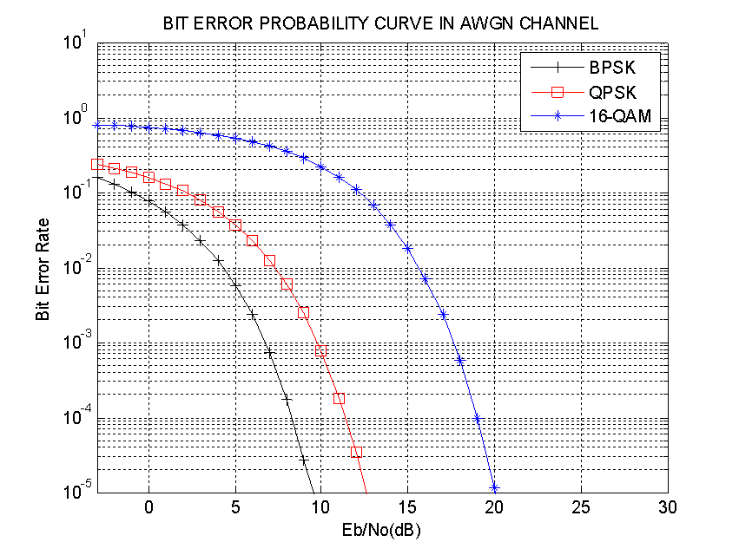

Figure 1: BER probability curve versus Eb/No.

1. CONCLUSIONS

Although a conclusion may summarize the fundamental remarks of the article, a concluding section is not required. In any case, it is advisable to write some conclusions in the article. In case you provide conclusions, do not use the summary as the conclusion. A conclusion section could be stated by referring to the relevance of the work or suggesting its applications and generalizations.

acknoWLEDGments

**It is recommended that the authors thank those who have allowed, helped and collaborated on obtaining main results referred to the article. In case it is appropriate to express acknowledgments, it is suggested to use a typical heading such as: "The authors wish to thank ..."**

REFERENCeS

[1] I. Tomkos, D. Klonidis, E. Pikasis, y S. Theodoridis, «Toward the 6G Network Era: Opportunities and Challenges», *IT Prof.*, vol. 22, n.o 1, pp. 34-38, Jan. 2020, doi: 10.1109/MITP.2019.2963491.

[2] W. H. Zurek, Ed., *Complexity, Entropy and the Physics of Information*, 1 edition. Redwood City, Calif: Westview Press, 1990.

[3] C. J. Vieri, «Reversible Computer Engineering and Architecture», PhD, MIT, Massachusetts, 1995.

[4] FA Division, «G.hn- “Next generation home network technology”», Ministry of Communications and Information Technology. Department of Telecommunications. Government of India., 2008.

[5] D. G. Vrachkov y D. G. Todorov, «Research Trends for Wireless Solutions in Automotive Ethernet», en *2019 X National Conference with International Participation (ELECTRONICA)*, May 2019, pp. 1-3, doi: 10.1109/ELECTRONICA.2019.8825630.

[6] «IEEE Standard for Information technology–Telecommunications and information exchange between systems Local and metropolitan area network–Specific requirements Part 11: Wireless LAN Medium Access Control (MAC) and Physical Layer (PHY) Specifications Amendment 5: Preassociation Discovery», *IEEE Std 80211aq-2018 Amend. IEEE Std 80211-2016 Amend. IEEE Std 80211ai-2016 IEEE Std 80211ah-2016 IEEE Std 80211aj-2018 IEEE Std 80211ak-2018*, pp. 1-69, ago. 2018, doi: 10.1109/IEEESTD.2018.8457463.

[7] «Worldwide software-defined radio demand to reach $27.3 billion by 2020 says MarketsandMarkets», Apr. 15, 2016. http://www.militaryaerospace.com/articles/2014/11/sdr-market-forecast.html (acceded Apr. 15, 2016).

AUTHORS SECTION

**A not numbered section will be included with an extension of no more than one paragraph regarding author information to declare institution and research interests, ORCID identification number, teaching category, and scientific category, membership in professional organizations, etc.**

CONFLICT of INTERESt

Please, specify here whether or not there is any conflict of interest of the authors or the institutions to which they belong concerning the content of the article reflected here.

CONTRIBUTIONS OF THE AUTHORS

It should specify the contribution of each author to the present article, taking into account their percentage of contribution and the aspects covered (e.g.: conceptualization, preparation, creation, and development of the article, critical review of each of the versions of the draft article and approval of the final version to be published, contribution to the idea and organization of the article, accurate suggestions for the confirmation of the final version)

* **Author 1**:
* **Author 2**:
* **Author 3**:

This journal provides immediate free access to its content under the principle of making research freely available to the public. The contents of the magazine are distributed under a Creative Commons Attribution-NonCommercial 4.0 Unported License. Copying and distribution of your manuscripts by any means are allowed, provided that you maintain the credit of the authors and do not make commercial use of the works.



LAST remarks

Before submitting your article, we recommend making the following final revisions:

1. Check the sequence of the headers.

2. Check the numbering of references, equations, tables, and figures.

3. Review citations in the text of references, figures, tables, and equations.

CONTACTS

If you have any questions or comments in the preparation of your article please go to the following email address:

telematica@tesla.cujae.edu.cu